**Detailed Information**

Retail Express Store Setup for

Translator Application – follows TranslatorHQ Store Setup

This document contains detailed information on:

* SKU’s and product variants
* Naming Conventions
* How Sales Channels and Source Groups work
* Bulk Editing

Updated - Wednesday, 16 May 2018

Contents

Product Variants Explained – Grouping a product by Style 4

Retail Express Example 4

ECommerce 5

ECommerce Variant 5

Product Attributes – Size / Style 6

DropBox – Cloud Naming Conventions Guide 7

Variant Images 8

Descriptions 8

TranslatorHQ Image store: 8

How do Sales Channels work? 10

Overview: 10

Example situations: 11

Where to maintain your settings: 12

How do source groups work? 12

Overview: 12

Examples: 14

Where to maintain your settings: 15

Order Processing – working with Automatic Orders 15

The Fulfilment Report 17

At POS 17

Using the Fulfillment Report 17

Using POS 18

Order Fulfillment – Transfers 19

Product Types 19

Bulk Editing Products in Retail Express 20

Creating new products only 21

Product Pricing 22

Product Stock Levels 22

Download 22

Editing Spreadsheet 23

Edit existing or create new products 24

Country and Outlet 24

Attributes 25

Download 25

Editing Spreadsheet 25

Getting Products ready for your Webstore 28

Upload saved Mass Upload 29

Appendix 1 – Options 32

This document should be read in conjunction with our Overview document. This supports the information contained in that document and is subservient to that product.

# Product Variants Explained – Grouping a product by Style

The ability to group products together offers many benefits:

• Search and product pages aren't cluttered

• Your customers can see available size/colour variations on the one product page

• You only have to maintain one product

You may have multiple products that come in multiple variations, such as sizes and colours, but choose to display the product only once on your web store with a drop down selection of the various attributes.

You can group your products together on your website automatically using the ManufacturerSKU in Retail Express.

The Manufacturer Code from Retail Express is used to group the variants in ECommerce as shown below by “Product”. This SKU is the link between Retail Express and ECommerce and the Supplier SKU, which includes variants such as size, links each product to its corresponding product in ECommerce.

## Retail Express Example

As shown below, In Retail Express the Product group is the **Manufacturer** SKU, whereas the **Supplier** SKU includes the size variants.

|  |  |  |
| --- | --- | --- |
| ProductId | SKU – *Supplier SKU* | Code – *Manufacturer SKU* |
| 139996 | MPL5CMP1410556MULXS | MPL5CMP1410556MUL |
| 139997 | MPL5CMP1410556MULS | MPL5CMP1410556MUL |
| 139998 | MPL5CMP1410556MULM | MPL5CMP1410556MUL |
| 139999 | MPL5CMP1410556MULL | MPL5CMP1410556MUL |

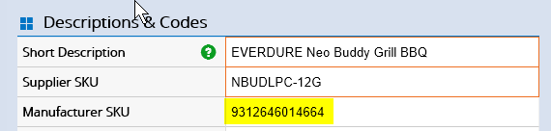

## ECommerce

In ECommerce the Manufacturer SKU is used as the Product Group and the Supplier SKU’s are variants that correspond to other options, such as size in the below example

|  |  |
| --- | --- |
| Product Group | Title |
| MPL5CMP1410556MUL | MINK PINK PRETTY PETALS PLAYSUIT - MULTI |

## ECommerce Variant

|  |  |  |  |  |  |
| --- | --- | --- | --- | --- | --- |
| barcode | option1 | position | price | product_id | sku |
| 139996 | XS | 1 | 37.48 | 941404545 | MPL5CMP1410556MULXS |
| 139997 | S | 2 | 37.48 | 941404545 | MPL5CMP1410556MULS |
| 139998 | M | 3 | 37.48 | 941404545 | MPL5CMP1410556MULM |
| 139999 | L | 4 | 37.48 | 941404545 | MPL5CMP1410556MULL |

This is how it looks in ECommerce 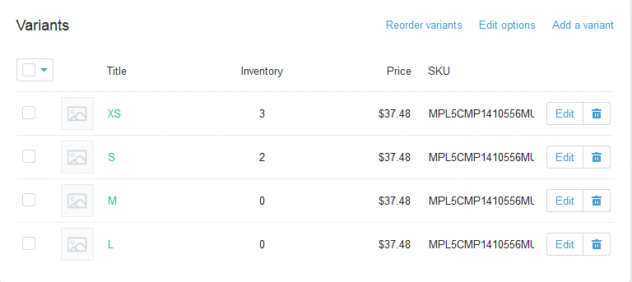and each product will link to the Retail Express Supplier SKU.

|  |  |  |  |  |  |  |  |  |  |  |  |  |  |  |  |  |  |  |  |  |  |  |  |  |  |  |  |  |  |  |  |  |  |  |  |  |  |  |  |  |  |  |  |  |  |  |  |  |  |  |  |  |  |  |  |  |  |  |  |  |  |  |  |  |  |  |  |  |  |  |  |  |  |  |  |  |  |  |  |  |  |  |  |  |  |  |  |  |  |  |  |  |  |  |  |  |  |  |  |  |  |  |  |  |  |  |  |  |  |  |  |  |  |  |  |  |  |  |  |  |  |  |  |  |  |  |  |  |  |  |  |  |  |  |  |  |  |  |  |  |  |  |  |  |  |  |  |  |  |  |  |  |  |  |  |  |  |  |  |  |  |  |  |  |  |  |  |  |  |  |  |  |  |  |  |  |  |  |  |  |  |  |  |  |  |  |  |  |  |  |  |
| --- | --- | --- | --- | --- | --- | --- | --- | --- | --- | --- | --- | --- | --- | --- | --- | --- | --- | --- | --- | --- | --- | --- | --- | --- | --- | --- | --- | --- | --- | --- | --- | --- | --- | --- | --- | --- | --- | --- | --- | --- | --- | --- | --- | --- | --- | --- | --- | --- | --- | --- | --- | --- | --- | --- | --- | --- | --- | --- | --- | --- | --- | --- | --- | --- | --- | --- | --- | --- | --- | --- | --- | --- | --- | --- | --- | --- | --- | --- | --- | --- | --- | --- | --- | --- | --- | --- | --- | --- | --- | --- | --- | --- | --- | --- | --- | --- | --- | --- | --- | --- | --- | --- | --- | --- | --- | --- | --- | --- | --- | --- | --- | --- | --- | --- | --- | --- | --- | --- | --- | --- | --- | --- | --- | --- | --- | --- | --- | --- | --- | --- | --- | --- | --- | --- | --- | --- | --- | --- | --- | --- | --- | --- | --- | --- | --- | --- | --- | --- | --- | --- | --- | --- | --- | --- | --- | --- | --- | --- | --- | --- | --- | --- | --- | --- | --- | --- | --- | --- | --- | --- | --- | --- | --- | --- | --- | --- | --- | --- | --- | --- | --- | --- | --- | --- | --- | --- | --- | --- | --- | --- | --- |
| When you group your products using the ManufacturerSKU, your web store will create the following products:  **Configurable / Variable product:** the "parent" of the group, and the product that needs to be maintained. This will be displayed to the visitors to your site with options below it. The SKU code that will be created on the web store for this product will be POS-SupplierSKU for each variant.  **Simple product:** the individual products as per Retail Express, containing information on pricing and inventory levels. The SKU code that will be created on the web store for these individual products will be POS-SupplierSKU.  Things to bear in mind:  • Any product in Retail Express that does not have a ManufacturerSKU won't be grouped, and a simple product will be created.  • Any product that is grouped in Retail Express with a ManufacturerSKU **MUST** have a unique size/colour variation, otherwise an error will occur during the synchronisation of the web site. For example, you cannot have two products grouped together that are both size 10 in blue.  **How to group your products**  The following checklist will help you to determine if you need to group your products together or not:.  ***Do you have the same products with size variations?***  Matching products with size variations can be grouped together, even if they don't have different colours. Simply leave the colour field blank. If you do use a colour for one product, then all products will need to have a size as well (they can be the same colour, as long as there is not the same size/colour combination)  ***Do you have the same product but with colour variations?***  Similar to the sizes, products with different colours in the same size, or different sizes, can be grouped together.  **Do you have a lot of configuration options beyond size and colour?**  We have found that one you exceed a couple of options mistakes are common. Images rarely reflect the choices made and can fool the customer. In these instances you should consider separating the products by varying the ManufacturerSKU  ***Do you want your customers to see each variation as an individual product?***  If you want each product's size/colour variation to appear as an individual product, you should not group your products together. Product Attributes – Size / Style Retail Express has product attributes that can synchronise to your web store, and displayed on the product page or used to assist in searching or categorisation if desired.  • Size (drop down)  • Colour (drop down)  • Season - Text  • Brand - Text  • Product Type (please note this is separate to your categories)  Your web store can have these configured to display on the sidebar or top of your product page or searching pages. Your customer will be able to use the attributes to filter their products and refine their search results.  More options - tags  SmartTags are a feature of Translator that allows you to define your own reasons for having tags. One of the most common requests is a “SALE” tag. But others can include anything you would then like to use to create a “Smart Collection” in Shopify that uses the tags to build a collection of products. “Made in NZ” for certain suppliers etc.  To create your attribute list in Retail Express:  • Navigate to Menu > System Settings.  • Click on the Menu option for your attribute e.g. Size Setup  • Enter the details and in the appropriate field and press Insert  • Repeat for any additional options  To update your products with new attributes you can apply them individually to each product by opening the product, selecting the new settings, and saving the product again.  If you have multiple products to update, a more efficient method would be to use the Mass Download feature in Retail Express. DropBox – Cloud Naming Conventions Guide If you are loading images and descriptions from DropBox or Cloud storage it is important the files are named correctly. The system IS case sensitive. If you want to use PNG or other file formats it may need a change to your configuration for Translator to look for those files.   |  |  |  | | --- | --- | --- | | Product ID: | 129150 |  | | Manufacturer SKU: | 793573730121 | *FOR THE PRODUCT* | | Supplier SKU: | CH1002 | *FOR THE VARIANT* |  |  |  |  |  |  |  |  |  | | --- | --- | --- | --- | --- | --- | --- | --- | | Examples: | |  |  |  |  |  |  | |  |  |  |  |  |  | |  | **Images:** |  |  |  |  |  |  | | Image One: |  | 793573730121_1.jpg |  |  |  |  |  | | Image Two: |  | 793573730121_2.jpg |  |  |  |  |  | | Image three: |  | 793573730121_3.jpg |  |  |  |  |  | |  |  |  |  |  |  |  |  | | **Supported Image Formats:** |  |  |  |  |  |  |  | |  |  | jpg |  |  |  |  |  | |  |  | png |  |  |  |  |  | |  |  | jpeg |  |  |  |  |  | | **Notes:** |  |  |  |  |  |  |  | | *Images will be called* ***ManufacturerSKU****_X.jpg where X = position number. ManufacturerSKU Will need to be in UPPERCASE, however the file extension will need to be in lowercase(jpg).* | | | | | | | | | |  Variant Images You can have lots of images for a product, variant images only support one per variant though. So each variant has only **one** image. These images are all attached to the main product and not to variants.  I think you can only have one image for “Variants” Master Product images allow 10 images but not variants.  ManufacturerSKU_OPTION_1.jpg  You still need the _1 suffix. Descriptions  |  |  |  |  |  |  |  |  | | --- | --- | --- | --- | --- | --- | --- | --- | |  |  |  |  |  |  |  |  | |  | **Descriptions:** |  |  |  |  |  |  | |  |  | 793573730121.htm |  |  |  |  |  | |  |  |  |  |  |  |  |  | | **Supported Description Formats:** |  |  |  |  |  |  |  | |  |  | htm |  |  |  |  |  | |  |  |  |  |  |  |  |  | |  |  |  |  |  |  |  |  | | **Notes:** |  |  |  |  |  |  |  | | *Descriptions are called ManufacturerSKU.htm ManufacturerSKU Will need to be in UPPERCASE, however the file extension will need to be in lowercase(htm).* | | | | | | | | | | |
|

## TranslatorHQ Image store:

We provide a login to the Image upload section on our website where clients can upload multiple image files at ones.

Below is a screen shot showing a select  or drag file option.

Translator I-IQ 
ABOUT 
OUR FURNITURE 
Upload Files Here - Selecting or Dragging 
DROP HERE 
This page allows uploading of images 
BLOG 
LOGIN 
POLICIES 
ADMIN 

**Naming Convention**

The images must be named with the Manufacturer SKU in the format “MANUFACTURE SKU_1.JPG”.

We will convert image names to all uppercase.

Example BA9232_1.JPG

If you have variants those variants would have appended  _2, _3 etc, as per the above definitions..

# How do Sales Channels work?

## Overview:

Sales Channels addresses the question:

**Into which outlet do I want my sales to be entered, my pricing to come from, and my inventory from which source groups?**

The best use of this is when you have multiple web stores all connected to the same Retail Express database. Using Sales Channels, you can specify a particular outlet for your sales to be entered against so that you have visibility of the sales from each web site. You can also maintain different pricing for each store, and a different inventory levels by picking and choosing various source groups.

All of this is completed through a Retail Express feature where the user combines their Source Groups into "Channels".

For each channel and it's associated outlets, you will need to set one outlet to receive orders into and base web store pricing from. This outlet is known as the **Primary Sales Outlet**.

Assigning one or more **Source Groups** to the Sales Channel will allow the user to control which outlets contribute their stock count to the channel's available stock i.e. how many products are available to sell online.

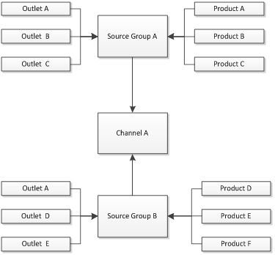

## Example situations:

A retailer with only one outlet, Outlet A, sets up a web store.

* **One Sales Channel, with Outlet A as the Primary Sales Outlet.**
* **They will also need one source group with Outlet A assigned to the group.**

A retailer with multiple stores and a warehouse would like all web store sales to be entered into the warehouse for processing, but the stock from their stores should be included for sale online as well.

* **This retailer will need one Sales Channel with the Warehouse as the Primary Sales Outlet**
* **One Source Group with the warehouse and all stores in the Source Group.**

A retailer with multiple stores and a warehouse would like all web store sales to be entered into the warehouse for processing. They have bulky products that can only be shipped from the warehouse (although the stores sell them, the Retailer doesn't want to ship from there). They do have smaller objects that can come from either the warehouse or the smaller retail stores.

* **One Sales Channel with the Warehouse as the Primary Sales Outlet**
* **Two Source Groups, one for the Bulky Products, and one for everything else. All bulky products are associated to the bulky source group only, other products to the other source group**
* **The sales channel will have both source groups selected**

## Where to maintain your settings:

Source groups are maintained via **Menu > System Settings > Locations/Outlets > Sales Channels**. For more information on setting up your Source Group, you should refer to your Implementation Console.

# How do source groups work?

## Overview:

When looking at setting up Source Groups, you need to first answer the following question:

**Where does the stock for my web store get fulfilled from?**

Source Groups allow you to control exactly where your products are sourced from when they're sold online. Answering the above question will prepare you for creating your Source Groups within Retail Express.

For example, you may have a warehouse that is purely for web store inventory and not your Retail outlets. Using source groups you could ensure the web store stock comes from the warehouse first, and only if sold out there it can be sourced from individual Retail stores. Your Retail stores will continue to operate as normal with their own inventory.

Source groups can also be used to calculate the estimated time of arrival (ETA) by factoring in any incoming Purchase Orders, as well as creating automatic Internal Transfer Orders (ITOs) when products need to be transferred between stores as a result of a sale placed online (please note these ITOs will need to be processed manually as part of processing online sales).

Once a source group has been created, you will be able to select the source group for your site via the Sales Channel (refer to the article on Sales Channels for more information).

Rules for a source group:

* **Each source group can have multiple products**
* **For an individual product, only one source group can be selected for each sales channel (for example, for Sales Channel A, source group A may be selected, but for Sales Channel B a different source group may be selected). This typically only applies for customers running multiple web sites from their Retail Express database.**
* **The same outlet may be selected in multiple source groups**
* **Outlets can be ordered in a hierarchy to control from which outlets the products are taken first**

In the example below, the web site has been set up to have the Sales Channel "Channel A", with the source groups "Source Group A" and "Source Group B" selected.

**Please note - single store retailers with an online store will still require at least one Sales Channel and Source Group - without this information product will not be able to synchronise.**

### 



## **Examples:**

**One Source Group:**

Best used where there is a single outlet, or multiple outlets with a specific order priority but all products follow the same pattern e.g. take from store A first, then store B, then store C and so on.

**Multiple Source Groups:**

Where there are products that are not available in specific outlets, or should be sourced in a different order from other products, you can set up a source group to control the outlets the products are available from. Bulky products are a great example of this, where they can only be sourced from specific warehouses and not individual retail stores.

## Where to maintain your settings:

Source groups are maintained via **Menu > System Settings > Locations/Outlets > Source Groups**. For more information on setting up your Source Group, you should refer to your Implementation Console.

# Order Processing – working with Automatic Orders

Having orders appear instantly in Retail Express offers many benefits for efficient store operations however it will mean a change to processes.

The preferred implementation is to take orders from the eCommerce system as soon as they reach the approved status (payment received) , then fulfil and ship the order from Retail Express.

The final step being to mark the order as fulfilled in the eCommerce system, sending the notification to the customer.

The Alternative option is used with systems doing auto-fulfilment such as Drop Shipping or auto shipping. In this instance the Translator system monitors whether the order has already been processed and if not posts the bill to Retail Express. This means the customer was told the transaction was fulfilled before it actually is.

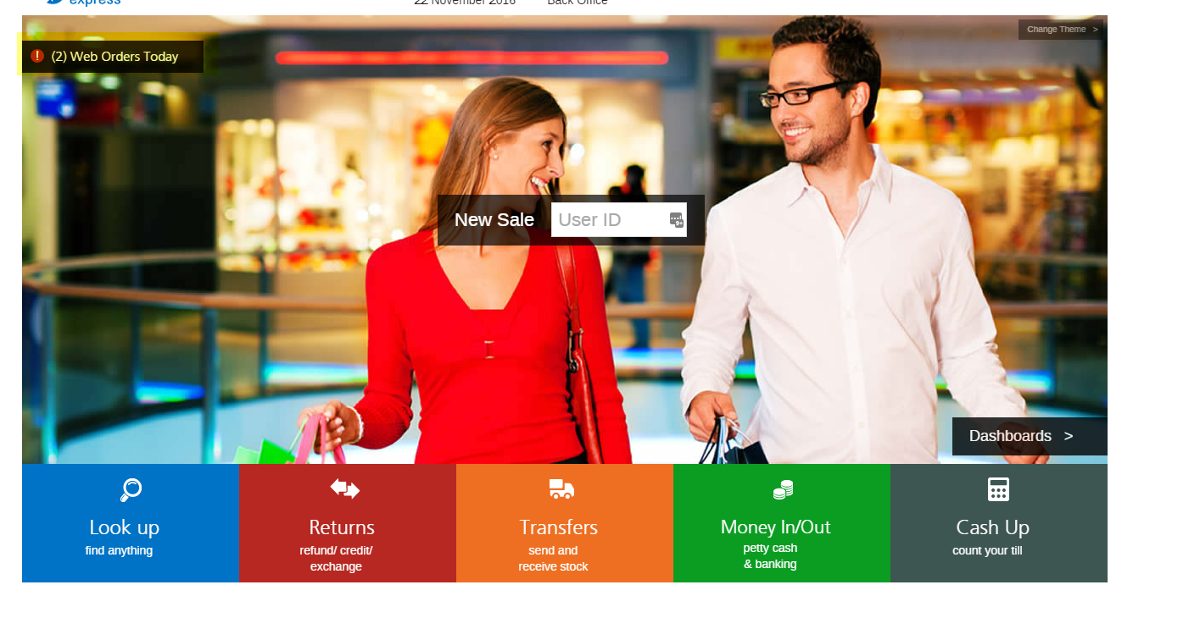

The web order notification appears on all outlets POS outlets. It will stay on the screen to alert you.

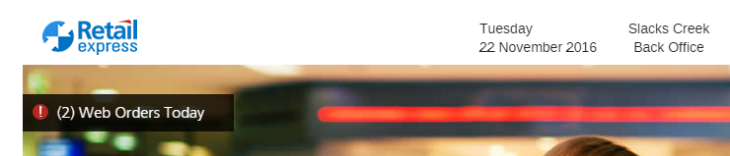

If there was a stock transfer requirement, this notification would appear on the outlet that the order needs to source stock from in order to fulfil the stock.

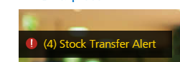

Based on the source priority in the source group.

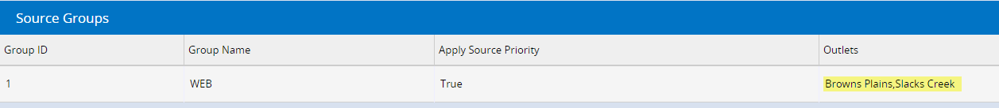

Retail Express is used to complete the sales - fulfilling products, marking them as processed and shipped is all managed in Retail Express.

Note: if an Internal Transfer has been created for this sale (where stock has been Sourced from another Outlet/Store) this needs to be managed as part of a separate process to ensure your stock levels are correct.

There are two methods for processing your web sales within Retail Express:

## The Fulfilment Report

Using the Fulfilment Report is the recommended and most efficient method for processing your web sales. The Fulfilment Report method allows you to:

* locate all outstanding orders to be Fulfilled and view if payment has been received
* dispatch multiple products AND sales orders through a single page
* filter by your requirements, including: date range, fulfilment location, delivery method/s (Tip: you can Map your Delivery Drivers in Retail Express to match your online Shipping Methods so that you can filter by specific delivery selections; this can be useful if you have offered a 'priority shipping' option and need to process these sales quickly)
* access Picking Lists, print labels and invoices from the report
* view Customer Comments associated with the Order
* open and edit the sale at POS via the 'E'dit button i.e: if you need to add a payment to the invoice

## At POS

Using POS is a simpler method for processing your sales on an individual sale-by-sale basis. POS Alerts provide a handy notification of the count of incoming Web Orders during the day, and links you to the "Search Sales Orders, Invoices & Quotes" window to action and process the sales.

As it's a simpler method, the filters for searching are limited and there are no bulk actions. Our recommendation when you have a large number of sales to process is to use the Fulfilment Report method and use POS Alert as a notification guide only.

## Using the Fulfillment Report

The Fulfilment Report is designed to allow you to view incoming sales, and process them accordingly.

navigate to: Inventory > Fulfillment Report OR Quick Links > Fulfilment Report

To search for outstanding online sales, the following filters are recommended:

* Ordered From and Ordered To to view orders within a specific date range
* Order Source to Web Service
* Delivery Status to Not Delivered
* to filter ONLY for invoices that have been paid, set the Order Status to Processed (Tip: view the related article Why is my online sale showing as awaiting payment in Retail Express?)
* set the Fulfil From to filter by specific Fulfilment Outlet/s
* the Delivery Driver can be filtered if you have set your delivery methods on your web store to be mapped to the Delivery Driver in Retail Express.
* Apply any other filters required to further refine your search

Click Search

Each individual product for each order is displayed, including any Customer Comments as detailed in the Public Comments field.

To dispatch your orders:

* check if there is a Transfer associated with the Order (details in the Source column). If so, this will need to be actioned prior to dispatching the Order.
* click XLS Picklist to generate a Pick List (in Excel format) to provide to your staff to "Pick" the products for dispatch.
* if you utilise Delivery Drivers, there are number of Runsheets that print various information. Print the Runsheet most suitable for your business needs.
* click Print > Invoices to include invoices with your delivery
* click Print > Labels to Print packing labels from your A4 Printer
* Enter the Disp quantity for each product you wish to dispatch. This can be done in one of three different ways:
* Manually enter the Disp Quantity against each Product that you wish to dispatch
* Use PLU Scan to scan Products using a barcode scanner (or manually type the barcode). Each time you scan a barcode it will increase the Disp column by 1 for the first result in the list.
* Use Copy Across to populate the Disp column of ALL results with the full Ordered quantity.

Once you have made changes, select either Submit or save.

## Using POS

The POS Home Screen periodically updates to display a count of incoming Web Orders for that calendar day. Once the Web Orders are processed this alert will disappear, until the next in-coming Order which prompts the alert to display again. In this way you're constantly updated of online sales.

Click the Web Orders Today alert to open Search Sales Orders, Invoices & Quotes and process your Orders. To dispatch an Order, click Open>, click the Fulfilment tab and Fulfil the Order as normal and then click Update to save and apply any changes

# Order Fulfillment – Transfers

Your Sales Channel normally called "Online") has a "Primary Sales Outlet" this is where the orders will appear.  
  
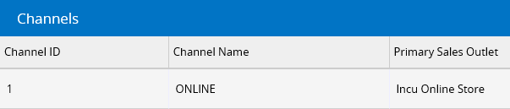​  
  
3. This has your Web source group as part of it:  
  
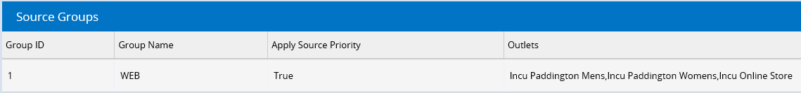​  
  
It will create a transfer when sourced from any outlet other than Your Primary Sales outlet.

.  
If the order is Fulfilled **before** the transfer is completed, the transfer will be cancelled. The order is marked “processed” before the transfer is complete but not fulfilled. A sale in Retail Express becomes "Processed" when it is fully paid. A sale can be in the Processed status but not fulfilled. However, if a sale is fulfilled before the transfer is completed, the transfer will get cancelled.

# Product Types

Under settings in Retail Express you can define the product Types that you can then assign Products too. Note that one product can only have one Category.

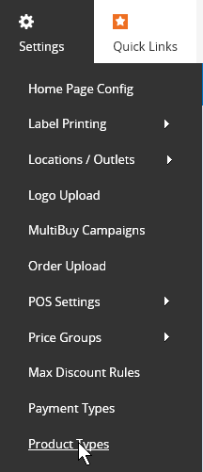

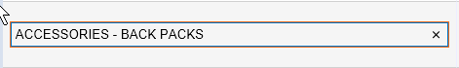

The normal Map for eCommerce systems like WooCommerce is to take the ProductTypeDesc from Retail Express to the Category. You can have sub categories in Retail Express by using a space dash and space between the categories.

So this above would be put in to ACCESSORIES and also ACCESSORIES – BACK PACKS

# Bulk Editing Products in Retail Express

***Menu > Inventory > Mass Download***

***and Menu > Inventory > Mass Upload***

These features are designed to let you create new or edit existing products within your database on mass.

By creating new or edit existing products in an Excel spreadsheet, you can make mass changes to various product attributes such as set new prices, change stock levels if needed, apply different product types, etc. Once altered, you can save the file and upload the spreadsheet directly into Retail Express, which will create or edit the products/changed included in the upload.

Where possible, we recommend saving a backup copy of your Mass Download file if you're unfamiliar with making bulk changes via the mass upload process. To do this simply click Menu > Inventory > Mass Download, leave all filters as they are and click Export Excel. Save this file somewhere safe for reference purposes if required.

## Creating new products only

**To create new products on mass in Retail Express: Visit**[**Menu > Inventory > Mass Upload**](https://ress.zendesk.com/hc/en-us/articles/215404828#section1)

To begin with you need to download the mass upload template from within the system as per the screenshot below.

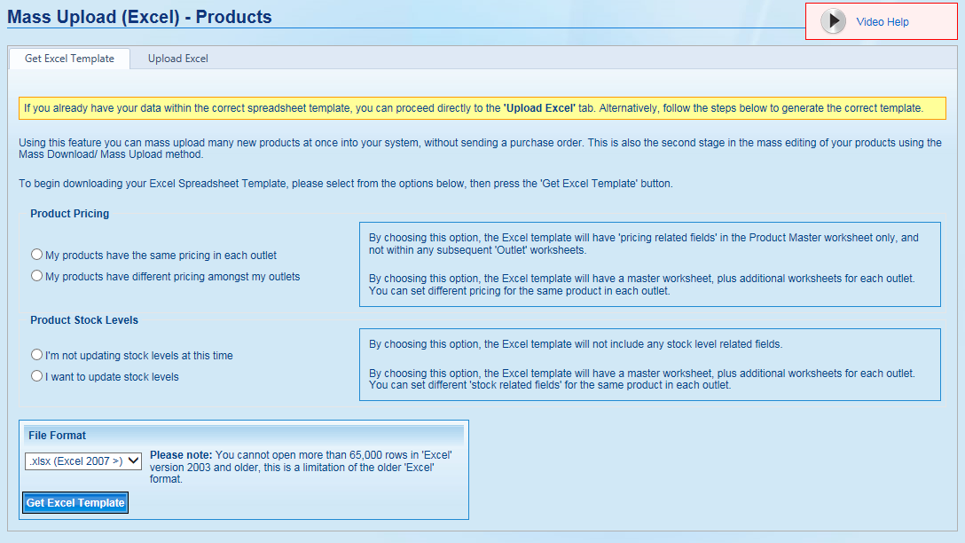

### Product Pricing

If you only have one outlet, or do not want the price to be different between your outlets, you can leave this set at "My products have the same pricing in each outlet" to generate an excel file that only have one worksheet, where you enter general product information, and does not allow the editing of pricing.

If you have multiple outlets and would like the pricing for the products you create to differ between your outlets, choose "My products have different pricing amongst my outlets"

### Product Stock Levels

If you do not want to enter an initial stock count (recommended), you can leave this set at "I'm not updating stock levels at this time" to generate an excel file that only have one worksheet, where you enter general product information, and does not allow the editing of stock in the outlets.

If you have multiple outlets or would like to enter an initial stock level for your products (not recommended), choose "I want to update stock levels"

### Download

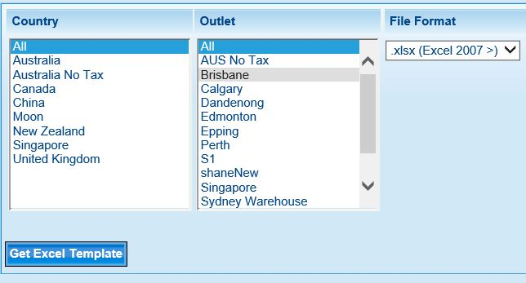

If you chose either "My products have different pricing amongst my outlets" in Product Pricing or "I want to update stock levels" in Product Stock Levels, you will see a field appear that looks similar to the image above.  
Here you will have to choose the outlet(s) that you would like to set outlet pricing or add stock levels for.

You can narrow down the Outlet list by specifying a Country, which will reduce the Outlets displayed to only Outlets within that Country.

Then you need to choose the Format you would like the spreadsheet in (.xlsx for users with Excel 2007 and above or .xls for users with Excel 2003) and press the "Get Excel Template" button, which will prompt you to save or open an Excel file of the format you chose.

### Editing Spreadsheet

Once you have either opened or saved and opened the spreadsheet, you can start filling out the worksheets within the excel file.

#### Product Master

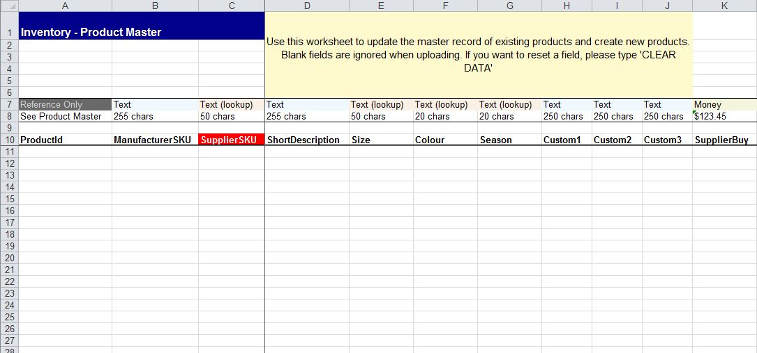

The Product Master worksheet contains all of the general product fields.

These fields are the global product details, meaning the information that is the same and shared across all outlets in Retail Express.

**The first field in Column A is the Product ID which will be automatically generated by the system, so please leave it blank**

The Mandatory fields in this worksheet are the SupplierSKU, ShortDescription, BuyPriceEx, POSPrice, ProductType and Supplier. These must be filled in to succesfully create a new product.

For more information on the other fields available in this worksheet, please refer to the "Main Page +/-" section of the Knowledge Base article titled "Edit Products or Packages Manually"

#### Outlet Worksheet

If you selected either "My products have different pricing amongst my outlets" in Product Pricing or "I want to update stock levels" in Product Stock Levels when creating the spreadsheet, you will see that the Excel file has multiple worksheets or tabs at the bottom of the excel window, including a "Product Master" worksheet/tab and an additional worksheet/tab for each outlet you chose.

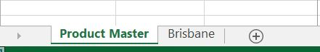

By clicking on the Outlet worksheet/tab, you will see a slightly different worksheet which includes some of the basic fields, as well as Outlet specific fields, such as Quantity, Outlet specific Buy, POS and Promotional pricing, Bin location and whether the product includes Tax or not at the specific outlet.

All you have to enter is the SupplierSKUs (of the products you want to have outlet specific information) into the SupplierSKU column, and the correlating Outlet specific information into the respective columns.

For more information on the other fields available in this worksheet, please refer to the "Pricing +/-" and "Inventory +/-" sections of the Knowledge Base article titled "Edit Products or Packages Manually".

## Edit existing or create new products

**To create or edit products on mass in Retail Express, first download a list of your existing products by visiting:**[**Menu > Inventory > Mass Upload**](https://ress.zendesk.com/hc/en-us/articles/215404968#section1)

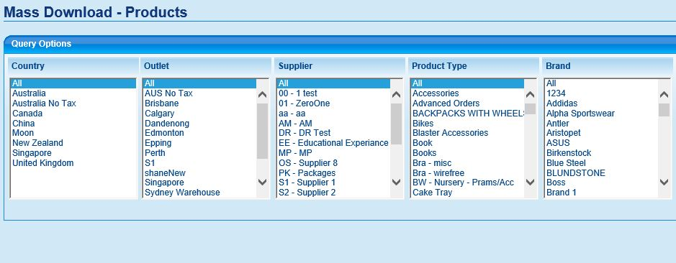

### Country and Outlet

If you only have one outlet or only want to edit or create products in specific outlets, you can choose the outlet(s) that you would like to edit. You can narrow down the Outlet list by specifying a Country, which will reduce the Outlets displayed to only Outlets within that Country. By default "All" outlets will be selected, and the excel file that is created will have a "Product Master" worksheet as well as a separate worksheet for each Outlet, containing the Outlet specific information.

Hint: If you do not want to edit any Outlet specific information, it is a good practice to choose a single Outlet so that there is only one Outlet worksheet in the file, which you can easily delete, leaving only the Product Master worksheet.

### Attributes

By selecting specific attributes, such as Supplier(s), Product Type(s), Brand(s), etc. you can reduce the number of products that are downloaded into the spreadsheet. This allows you to easily create an Excel file that has been reduced down to only the product(s) that you would like to edit, and will not include all of the other extraneous products.

You also have the option of including/excluding disabled products and product long Descriptions, both of which are excluded by default.

### Download

Simply choose the Format you would like the spreadsheet in (.xlsx for users with Excel 2007 and above or .xls for users with Excel 2003) and press the "Get Excel Template" button, which will prompt you to save or open an Excel file of the format you chose.

### Editing Spreadsheet

Once you have either opened or saved and opened the spreadsheet, you can start editing the worksheets within the excel file.

#### Product Master

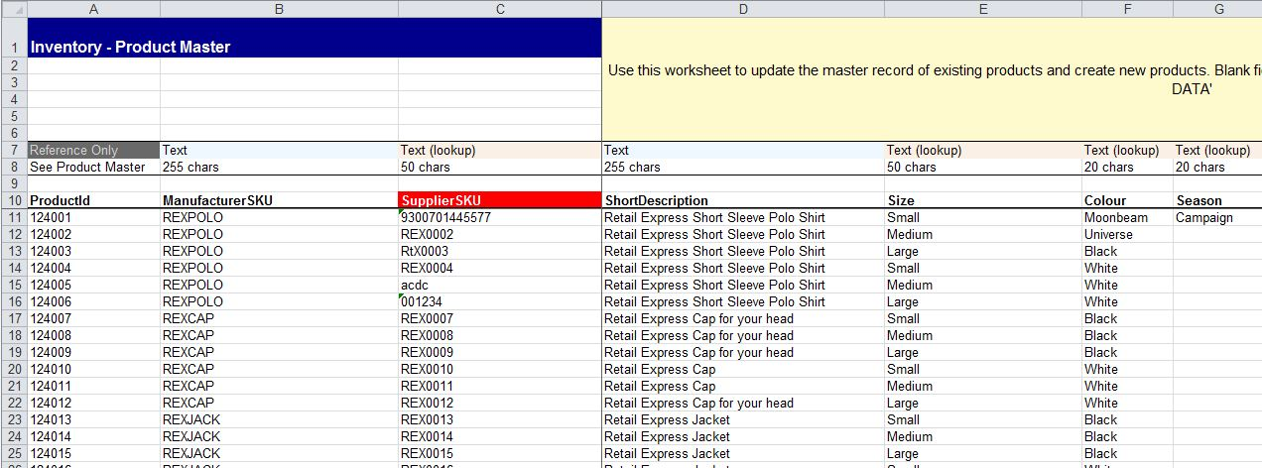

The Product Master worksheet contains all of the general product fields.

These fields are the global product details, meaning the information that is the same and shared across all outlets in Retail Express.

**The first field in Column A is the Product ID which has been automatically generated by the system, so please do not change it.**

You can edit products by typing over the old information with new information1, create new products by entering the new product information into the spreadsheet from the bottom of the list, or remove information by typing the words "CLEAR DATA" over the data you want removed2.

The Mandatory fields in this worksheet are the SupplierSKU, ShortDescription, BuyPriceEx, POSPrice, ProductType and Supplier. These must be filled in to successfully create a new product.

For more information on the other fields available in this worksheet, please refer to the "Main Page +/-" section of the Knowledge Base article titled "Edit Products or Packages Manually"

*1 - You can update the SupplierSKU (Barcodes) via Mass Upload*

*2 - Mandatory Fields cannot have data removed, as these are required by Retail Express and cannot be blank, errors will occur during the upload if there are problems such as required fields missing.*

#### Outlet Worksheet

You will see that the Excel file has multiple worksheets or tabs at the bottom of the excel window, including a "Product Master" worksheet/tab and an additional worksheet/tab for each outlet you chose.



By clicking on the Outlet worksheet/tab, you will see a slightly different worksheet which includes some of the basic fields, as well as Outlet specific fields, such as **Quantity,** Outlet specific Buy, POS and Promotional pricing, Bin location and whether the product includes Tax or not at the specific outlet.

**It is important if you are not wanting to update the stock quantities when uploading, that you empty/clear out the quantity column on the outlet sheet, or remove the outlet sheet all together if not making outlet specific changes.**

If you leave the existing quantities in place, and are trading/selling products whilst you are making your changes to this template, upon upload the available quantity will be set to whatever values are in the quantity column. This means any stock level changes since you downloaded the file will be reset upon upload unless the quantity column is cleared/emptied out.

To make outlet specific changes to a product, all you have to enter is the Product ID and or SupplierSKUs (of the products you want to have outlet specific information) into the SupplierSKU column, and the correlating Outlet specific information into the respective columns.

## Getting Products ready for your Webstore

Drag the value of the TRUE cell or fill down in the export to Web service down to populate the columns values for each product you would like to appear on the Web store.

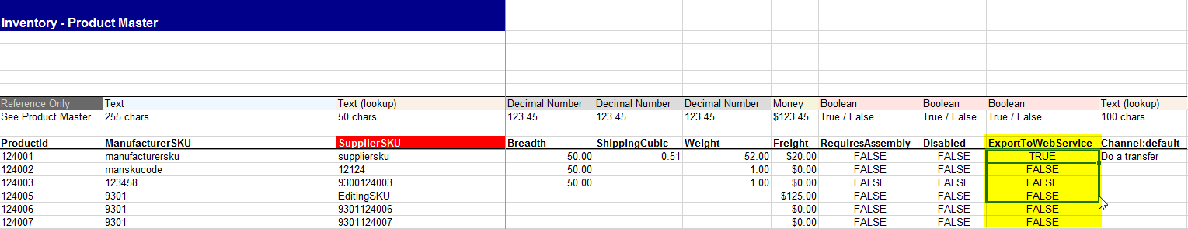

Set the Default Sales channel to the name of the Sales Channel you have setup in Retail Express for each product you would like to appear on the Web store.

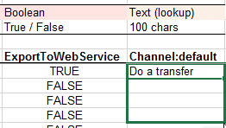

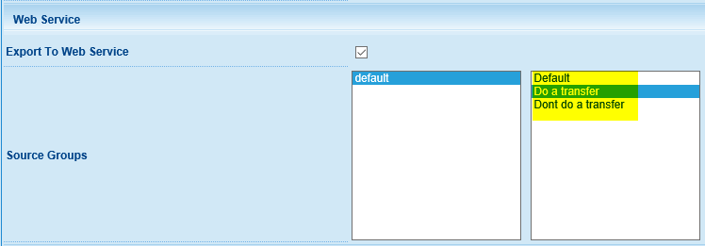

Please note that your Sales Channel and Source Group may be named differently.

## Upload saved Mass Upload

**To upload your saved mass upload file in Retail Express: Visit**[**Menu > Inventory > Mass Upload**](https://ress.zendesk.com/hc/en-us/articles/215404968#section1)

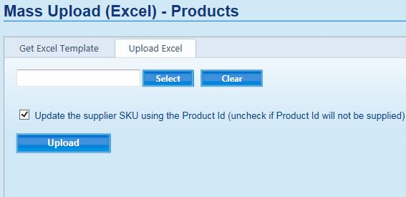

When you click on the "Upload Excel" tab at the top of the page you will be presented with a section like the image above

Simply press the "Select" button to choose the saved Excel file from your computer and, once you have chosen the correct file, press "Upload".

**Important : If you are uploading existing products, then tick the box that says :**

"Update the supplier SKU using the Product Id (un-check if Product Id will not be supplied"

Top of Form

Bottom of Form

**If you are uploading all new products, then untick that box.**

You will see a status bar showing the progress of uploading the file, which will either result in the file uploading successfully, or will generate an error in the instances where there is something wrong with the information.

#### Successful Upload

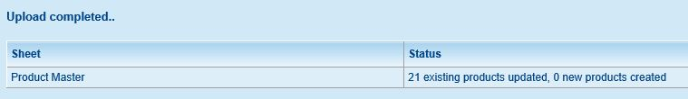

A successful upload will display a message similar to the image above, and will include information such as how many existing products were updated, how many new products were created and how many outlet specific information was updated.

#### Unsuccessful Upload

An unsuccessful upload will display one of two types of errors.

If there are only a few small errors, you will see a list of the errors listed on screen, often with an action that can be applied to fix the error.

For example, if you have a product with a new colour that you have not yet set up in Retail Express, there will be a button on the error that you can press to create the colour automatically.

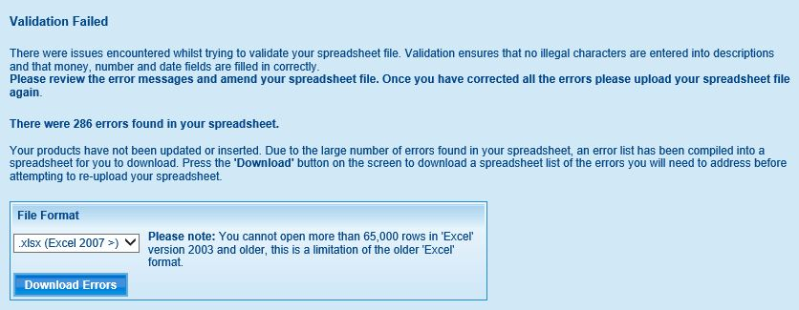

If there are a lot of errors, Retail Express will generate a warning message like the image above, along with an Error spreadsheet that you will have to download.

If either of these errors occur, you will need to review the error messages and amend your spreadsheet file or Retail Express itself to resolve the issues.

Once you have corrected all the errors please upload your spreadsheet file again.

# Appendix 1 – Options

|  |  |  |
| --- | --- | --- |
| **ModuleName** | **Description** | **Enabled** |
| HideNoStock | Hide the product when it has no stock | N |
| HideNoImage | Hide the product when it has no image attached | N |
| ProductSync | Enable Products to be updated | Y |
| StockSync | Enable stock and pricing updates | Y |
| CustomTags | Execute custom SP for client | Y |
| FixErrors | OVERRIDE to fix errors (DO NOT ENABLE) | N |
| SupportJPG | Support JPG image extensions | N |
| SupportPNG | Support PNG image extensions | N |
| SupportJPEG | Support JPEG image extensions | N |
| SupportWordHTML | Clean word tags from HTML | N |
| UseHTM | Use HTM/HTML descriptions | N |
| WooStore | Woo Commerce store | Y |
| NewProductSync | Allow for new products to be added | Y |
| useClothingOptionsWoo | Set options titles in Woo Commerce (Setup in data map) | N |
| SendImage | Attach an image to the product | N |
| CheckDropboxForImage | Check Dropbox for an image | N |
| ECommerceStore | ECommerce Store | N |
| NetoStore | Neto Store | N |
| CheckECommerceForImage | Check ECommerce for an image | N |
| HideOnFirstImport | Hide the product on creation | Y |
| NameECommerceOptions | Set the ECommerce option titles (Setup in data map) | N |
| useBase64Images | Use base 64 images (Stored in SQL) | N |
| supportShipping | Support shipping | N |
| sendOrderLog | Send order error log | N |
| attachREXCustomer | Attach the customer id into ECommerce when creating an order in REX | N |
| UseVariantImage | Use Variant images - 1 only per colour | N |
| sendTransactionalEmail | Send transactional email after purchase (Order sync) | N |
| fulfilledOrdersOnly | Sync only fulfilled orders in REX | N |
| ForceUpdate | Force update every product even if the stock hasn't changed | Y |
| AllowDeletes | Allow the Translator to delete products | N |
| UseGoogleShoppingMetadata | Google Shopping Metadata | N |
| UseGoogleCustomProduct | Google Shopping Custom Product Category | N |
| MailChimp | MailChimp Integration enabled | N |
| ThankQ | ThankQ Donation management Integration of completed orders | Y |
| SalesForce | Salesforce Integration of completed orders | N |
| compareREXPrices | Notification for changes in Pricing in Retail Express | N |
| mcValidateEmails | Mailchimp Integration email validate with Domain - Slower | N |
| mcUseOrderInfo | MailChimp - Update last order information in the list | N |
| hideCoreProducts | Even If product is core apply hiding options | Y |
| BigComStore | BigCommerce Store | N |
| allowBackOrders | If new product Allow back orders defaulted on, Normally off | N |
| useCustomDataMap | Not in use | N |